Sona College of Technology, Salem-5
Department of EEE
International Conference on Power Engineering (POWERCOIN’20)

The Department of Electrical and Electronics Engineering organized a two days International Conference on Power Engineering (POWERCOIN’20) at Sona College of Technology during March 12-13, 2020.
Dr. Mazlan Abbas, CEO- FAVORIOT Sdn Bhd, Malaysia and Mr.Prakash Bhattarai, R & D Test Engineer, Carbon Track PTY Ltd, Australia were the Guests of Honour and they inaugurated the conference proceedings. Dr. Mazlan delivered a key-note lecture on the topic “IoT- The Key Technology for Fourth Industrial Revolution” and Mr. Prakash Bhattarai delivered a key-note lecture on the topic “Application of IoT for efficient Energy Management” to all the participants. Both the lectures were informative and useful for all participants.
A total of 123 research papers were registered and presented in various paper presentation sessions held during the two days. The research papers were presented in the areas of Power system, Power electronics and drives, Smart Grid, High voltage Engineering, IoT applications in power systems, Cyber security applications, Robotics and Automation, Electrical vehicle technology, Non-Conventional energy systems etc.
A panel discussion on the topic “Industry 4.0- Challenges and Opportunities” was conducted on 13.3.2020. The panel team of nine members involved reputed industry experts and academicians. They presented and discussed the scope for latest digital technologies namely IoT, Additive manufacturing, Big data analytics, Block chain, Soft computing, E- mobility etc. and their impact in Fourth Industrial Revolution.

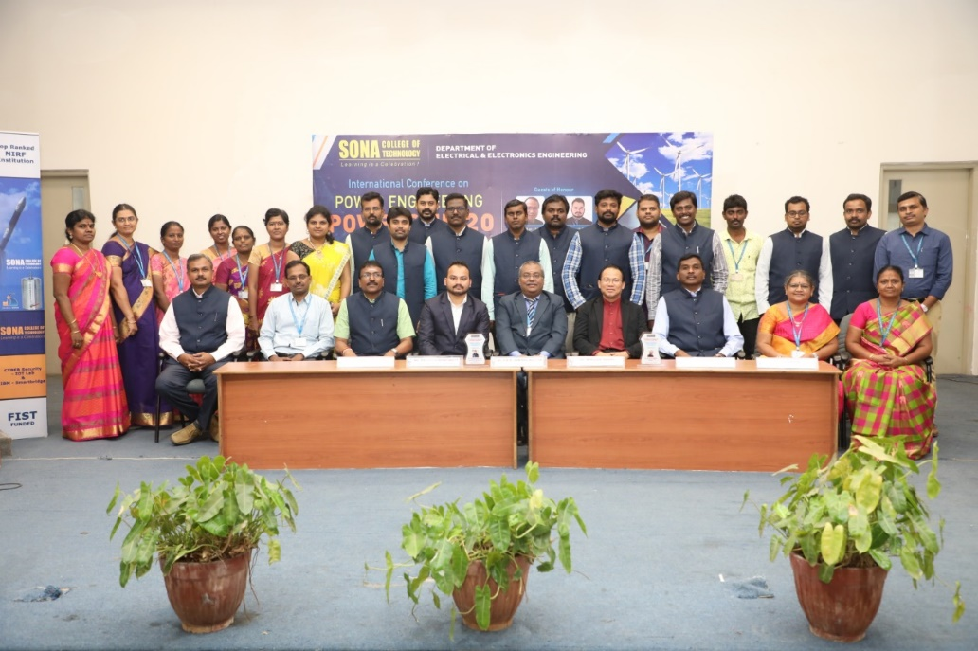
The conference was highly informative and the participants gave positive feedback on all the conference proceedings during the valedictory function.

