NATIONAL SERVICE SCHEME
ANNA UNIVERSITY OF TECHNOLOGY: CHENNAI
NSS ACTIVITIES FOR THE HALF YEAR: 2013– 2014

- Name of the college : SONA COLLEGE OF
TECHNOLOGY, SALEM

- Total No. of NSS Units : 3 UNITS

- Total No. of NSS Volunteers : Male : 88 Volunteers
Female: 77 Volunteers
Total : 165 Volunteers

- Regular Programmes
- Target (in hours) for the year : 200
- Achievement in the half yearly (in hours) : 92
- Achievement up to the end of the half yearly
(In hours) : 92
- Percentage to target : 76.7%

- Special Camps
- Whether the Special camp for the year 2012 – 2013
Conducted or not : NOT
- If Conducted give Period details : NIL
- If not conducted give the tentative date for the
Special camp : December last Week
S.NO | DATE | EVENTS |  |  | No. of Volunteers |  |  |  |  |  |  | No. of Beneficiaries
 |  |  |  |  | Boys |  | Girls |  |  | Total
1 | 29.07.2013  MONDAY | FRESHERS DAY |  |  | 30 |  | 58 |  |  | 88 |  | 88
2 | 9.008.2013-11-08-2012 | SWAMI VIVEKANANDHA ILAIGNAR ELUCHI MUGAAM |  |  | 6 |  | - |  |  | 6 |  | 6
3 | 15-08-2012 | INDEPENDENCE DAY CELEBRATION |  |  | 42 |  | 25 |  |  | 67 |  | 67
4 | 18.08.2013 | VISIT TO” BLIND SCHOOL IN SHEVAPET” |  |  | 24 |  | 21 |  |  | 45 |  | 45
 |  | VISIT TO ”GOVERNMENT DEAF AND DUMB SCHOOL” |  |  | 17 |  | 18 |  |  | 35 |  | 35
 |  | VISIT TO “ KARUNYA ILLAM” |  |  | 24 |  | 22 |  |  | 46 |  | 46
SADBHAVANA DIWAS EVENTS
5 | 21.08.2013 |  | KNOW THE DAY |  |  | 30 |  | 25 |  |  | 55 | 55
6 | 22.08.2013 |  | DEBATE |  |  | 25 |  | 24 |  |  | 49 | 49
7 | 22.08.2013 |  | SPEECH |  |  | 20 |  | 15 |  |  | 35 | 35
8 | 23.08.2013 |  | NAMING THE UNKNOWN |  |  | 29 |  | 31 |  |  | 60 | 60
9 | 26.08.2013 |  | CAPTION IT AND TURN COAT |  |  | 27 |  | 26 |  |  | 53 | 53
10 | 27-08-2013 |  | SEMINAR ON “ YOUTH IN AGRICULTURE” |  |  | 41 |  | 37 |  |  | 78 | 78
11 | 31.08.2013 |  | WORKSHOP ON “ DISASTER MANAGEMENT” |  |  | 88 |  | 77 |  |  | 165 | 165
12 | 02.09.2013- 06.09.2013 |  | LOTUS EYE CAMP |  |  | 1064 BENEFICIARIES
13 | 04.09.2013-06.09.2013 |  | SELECTION TEST |  |  | 160 VOLUNTEERS SELECTED
14 | 07.09.2013 |  | PLASTIC ERADICATION PROGRAMME |  |  | 39 |  | - |  |  | 39 | 39
15 | 16.09.2013 |  | TREKKING |  |  | 73 |  | 65 |  |  | 137 | 137
NSS DAY EVENTS
16 | 19-09-2013 |  |  | I YEAR- JAM |  | 60 |  | 50 | 110 |  |  | 110
 |  |  |  | II YEAR- BOOK REVIEW |  | 47 |  | 43 | 90 |  |  | 90
17 | 20-09-2013 |  |  | I YEAR- CREATIVE WRITING |  | 20 |  | 25 | 45 |  |  | 45
 |  |  |  | II YEAR- PHOTOGRAPHY |  | 33 |  | 24 | 57 |  |  | 57
18 | 23-09-2013 |  |  | I YEAR-WEALTH FROM WASTE |  | 70 |  | 55 | 125 |  |  | 125
 |  |  |  | II YEAR- MULTIMEDIA AND POSTER PRESENTATION |  | 40 |  | 25 | 65 |  |  | 65
19 | 21.08.2013 |  |  | ORIENTATION PROGRAMME |  | 62 |  | 54 | 116 |  |  | 116
20 | 24-09-2013 |  |  | NSS DAY CELEBRATION |  | 140 |  | 123 | 263 |  |  | 263
21 | 24-09-2013 |  |  | PUTHIYA THALAIM URAI EVENT |  | 30 |  | - | 30 |  |  | 30
22 | 28-09-2013 |  |  | SATHYA SAI WORKSHOP (PHASE II) |  | 28 |  | - | 28 |  |  | 28
23 | 01.10.2013 |  |  | SEMINAR ON “A STRONGER NATION AND VOLUNTARY BLOOD DONATION” |  | 65 |  | 34 | 119 |  |  | 119
24 | 03.10.2013 |  |  | EKAM FOUNDATION EVENT- GH CLEANING ACTIVITY |  | 46 |  | - | 46 |  |  | 46
25 | 05.10.2013 |  |  | EKAM FOUNDATION EVENT –COLLECTORATE CLEANING ACTIVITY |  | 46 |  | - | 46 |  |  | 46
26 | 05.10.2013 |  |  | SATHYA SAI EYE CAMP |  | 10 |  | - | 10 |  |  | 10
27 | 26.10.2013 |  |  | SEMINAR -“SWAMI VIVEKANANDHA’S RELEVANCE IN MEETING THE CHALLENGES OF 21ST CENTURY “ |  | 600 |  | 500 | 1100 |  |  | 1100
28 | 15.11.2013 |  |  | SWAMI VIVEKANANDHA RATHA YATRA |  | 83 |  | 77 | 160 |  |  | 160
29 | 03.01.2014  To  03.01.2014 |  |  | SPECIAL CAMP IN ( MURUGAPATTI, LAGUVAMPATTI AND PETHAMPATTI,) |  | 80 |  | 70 | 150 |  |  | 150
30 | 19.01.2014 |  |  | POLIO CAMP ( PONNAMAPET & SURAMANGALAM) |  | 70 |  | 55 | 125 |  |  | 125
31 | 26.01.2014 |  |  | REPUBLIC DAY |  | 45 |  | 36 | 81 |  |  | 81

BLOOD DONATION:
Our NSS volunteers donated around 345 units of blood during the academic year 2013-2014 to various hospitals in and around SALEM.
FRESHERS DAY
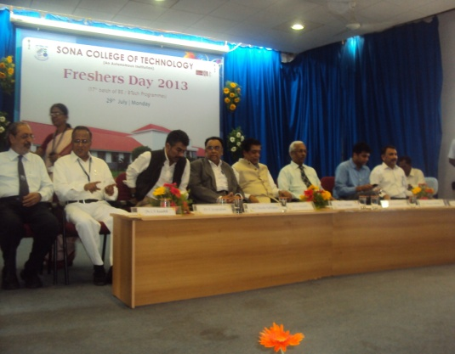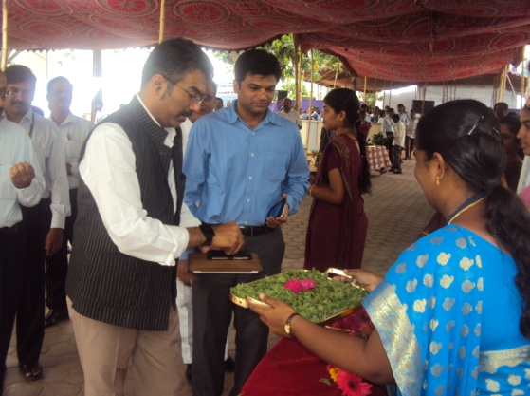
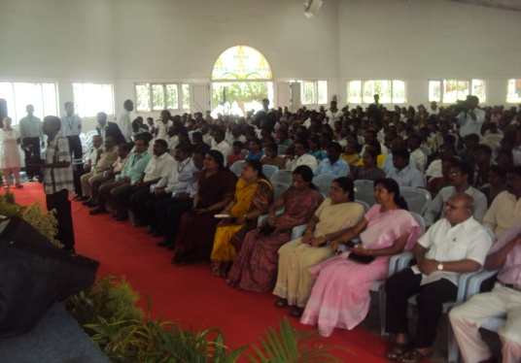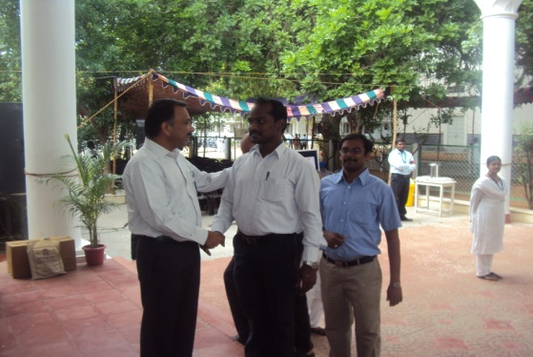
” Swami Vivekananda” Ilaignar Eluchi Mugam

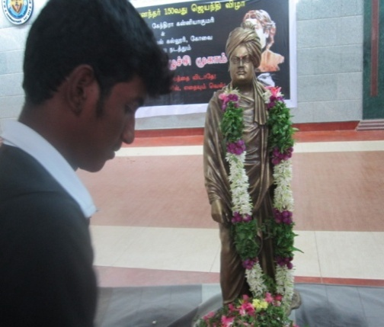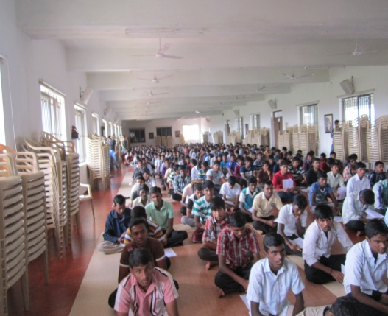

INDEPENDENCE DAY

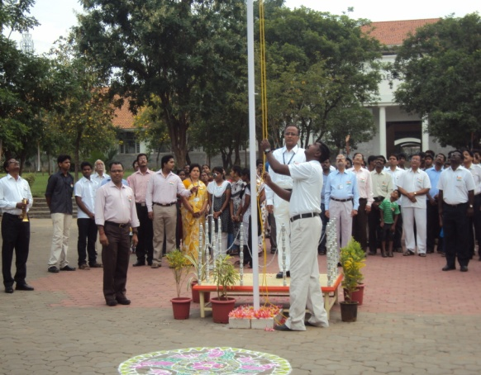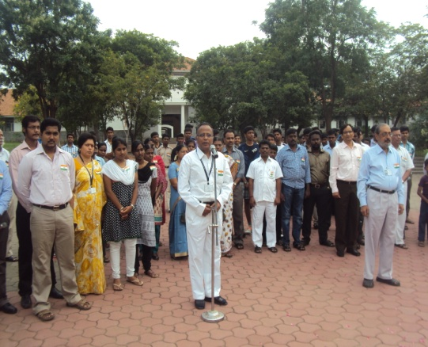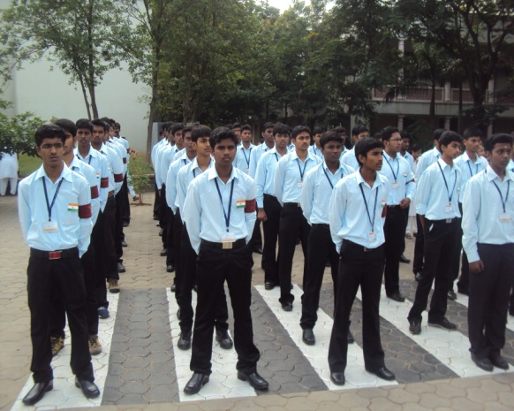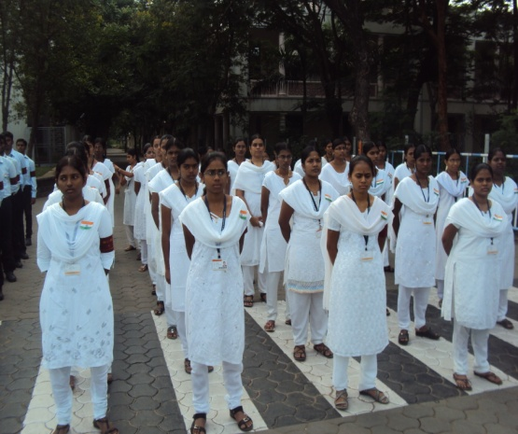

ORPHANAGE VISIT

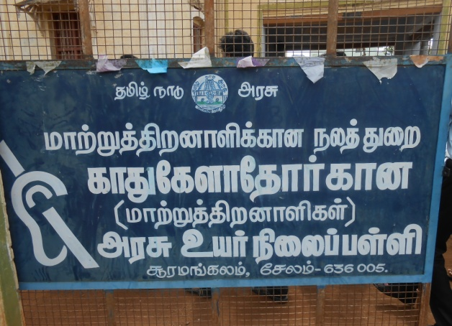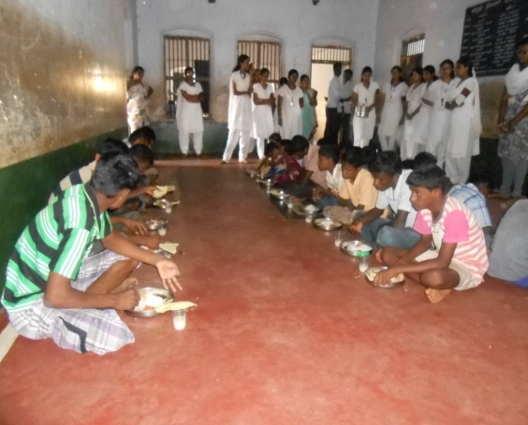
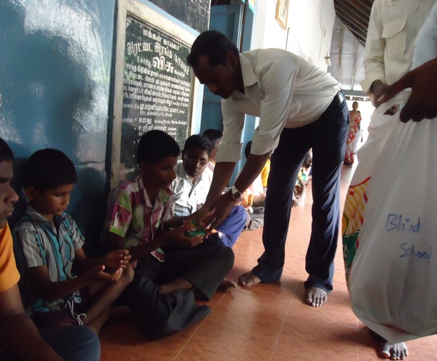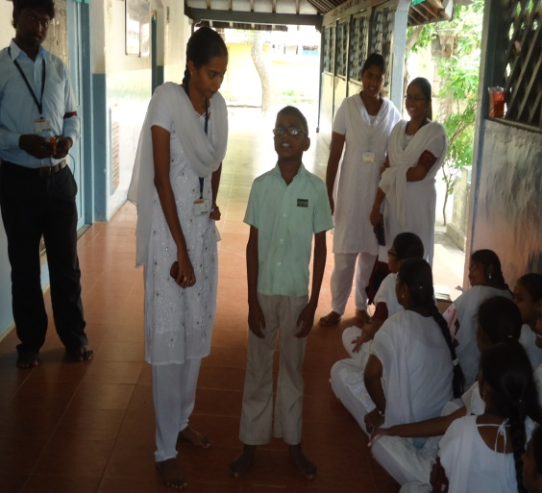

SADBHAVANA DIWAS
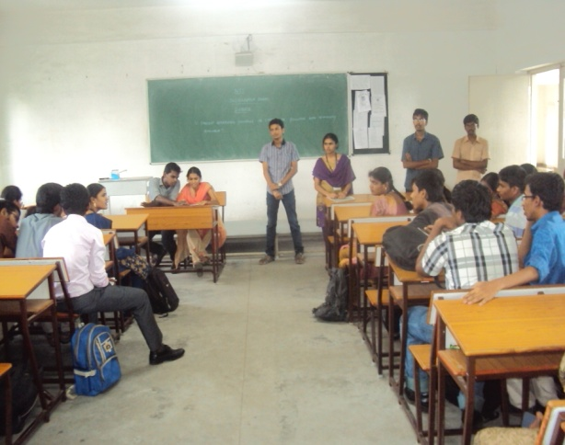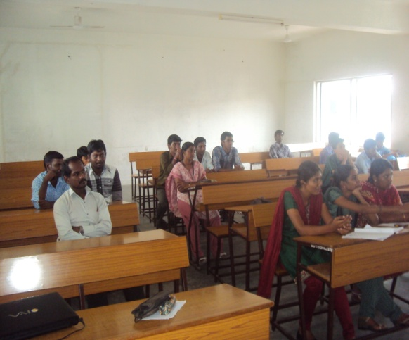

LOTUS EYE CAMP
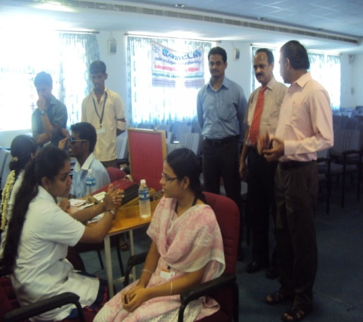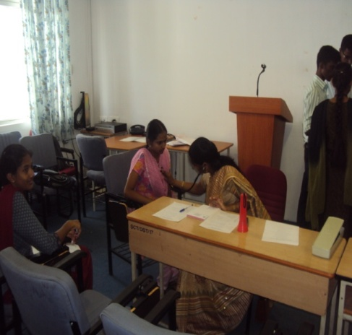
SELECTION TEST

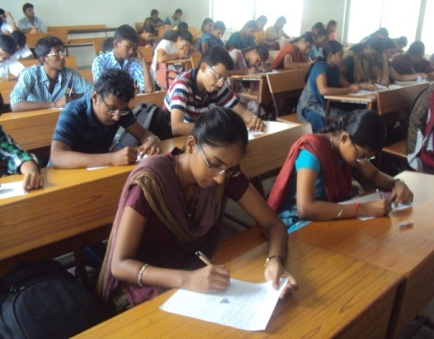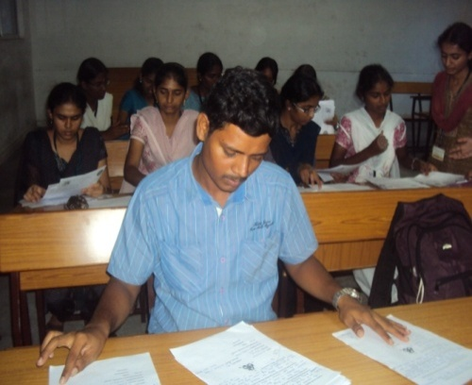

PLASTIC ERADICATION REPORT

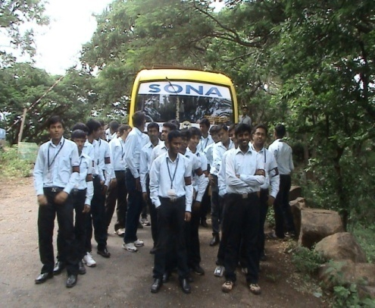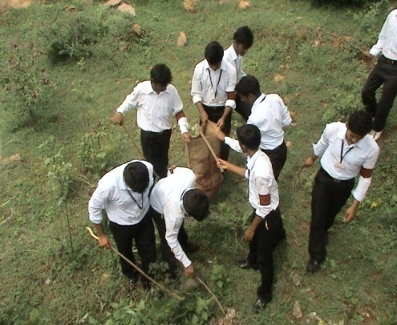

TREKKING
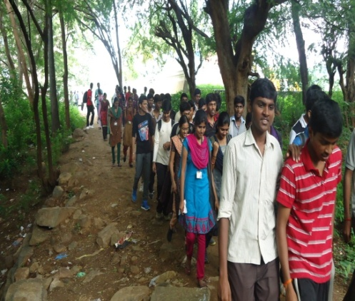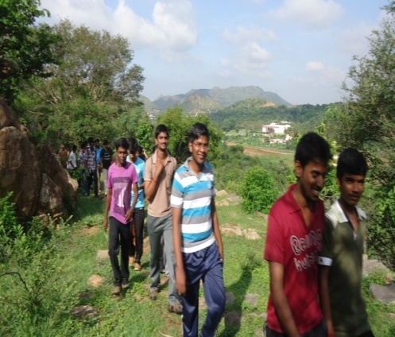

ORIENTATION PROGRAMME

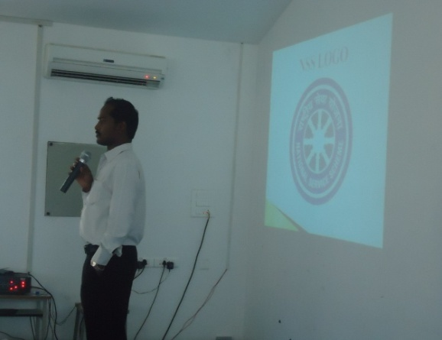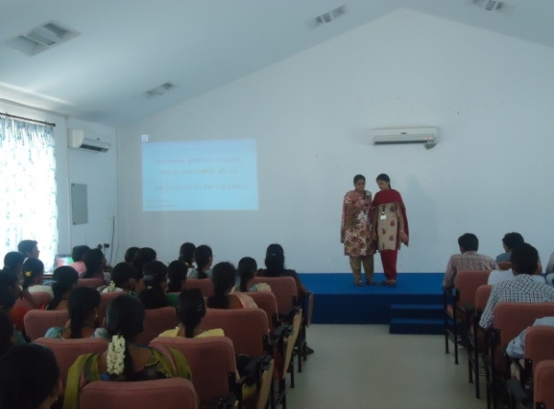

NSS DAY CELEBRATION
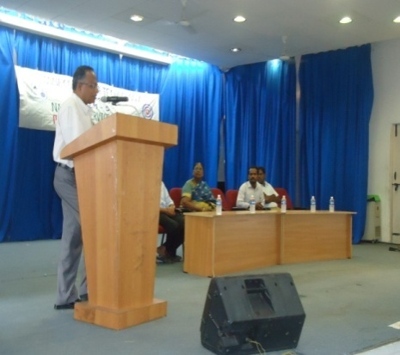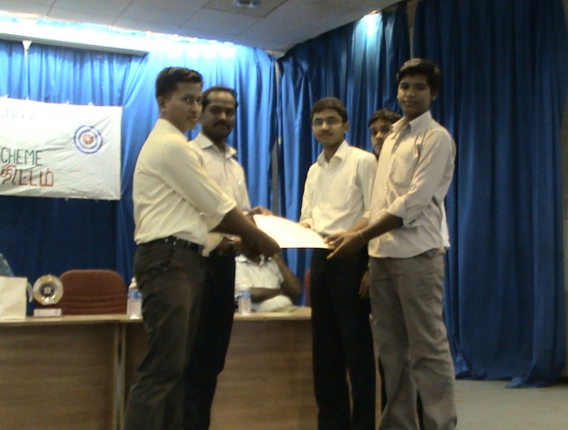

PUTHIYA THALAIMURAI QUIZ COMPETITION
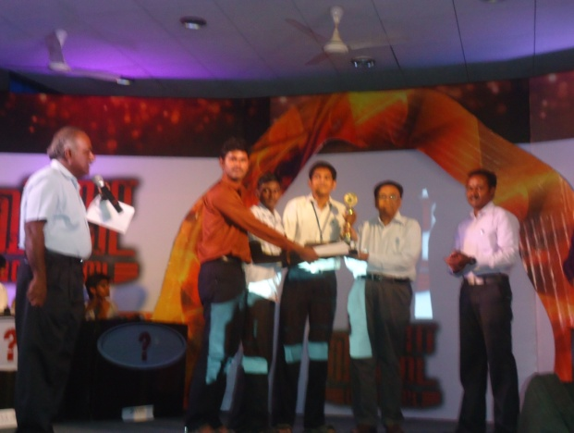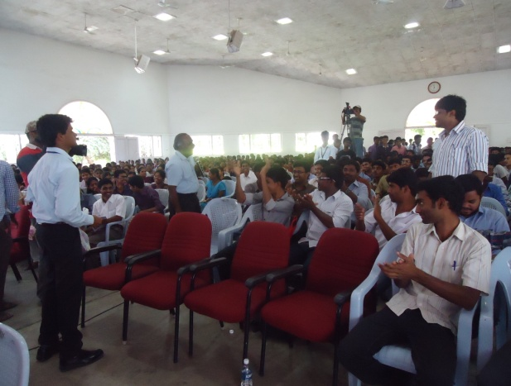
SATHYA SAI WORKSHOP (PHASE II)
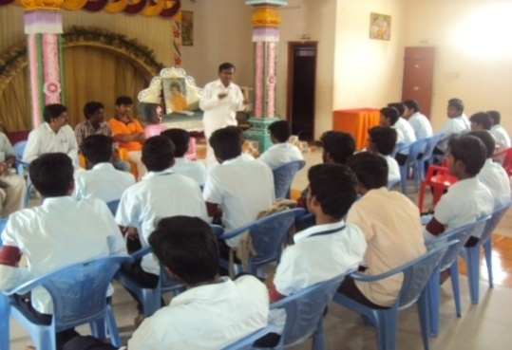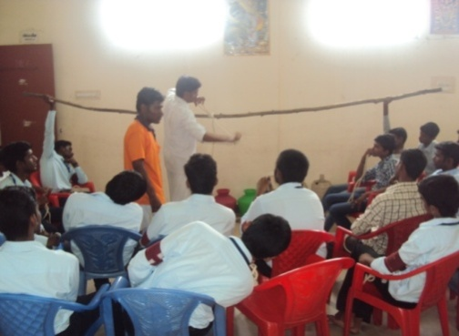
BLOOD DONATION SEMINAR
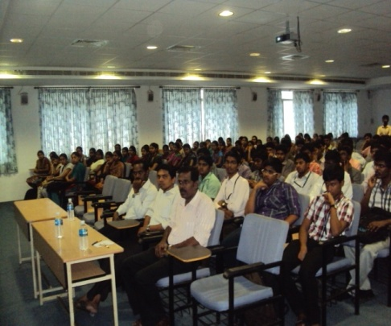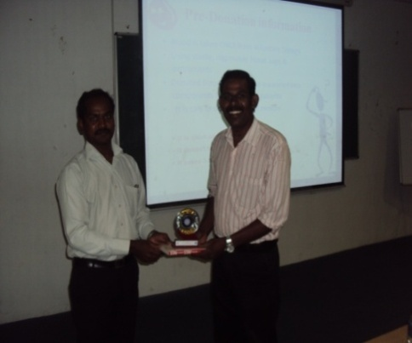

EKAM FOUNDATION EVENT (GH)
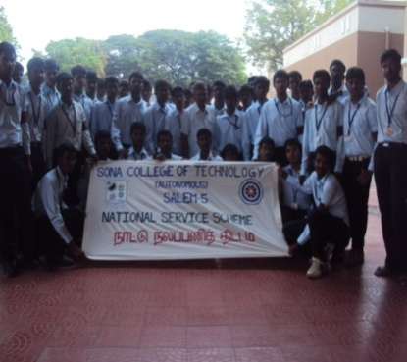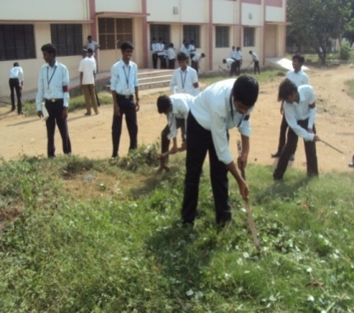

EKAM FOUNDATION EVENT (COLLECTORATE)
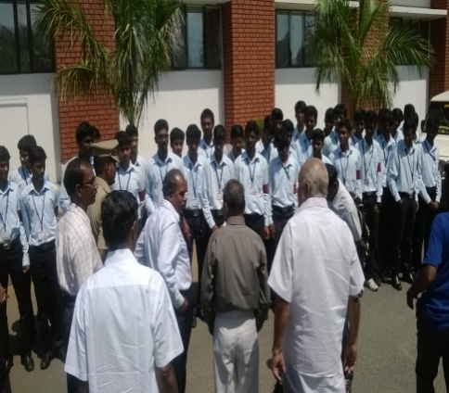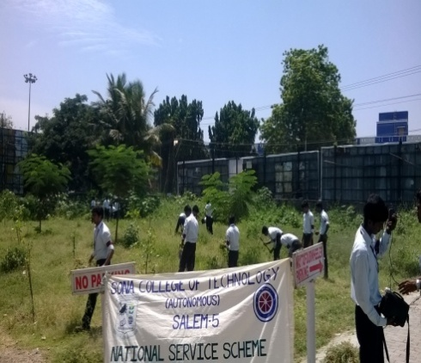

SATHYA SAI EYE CAMP
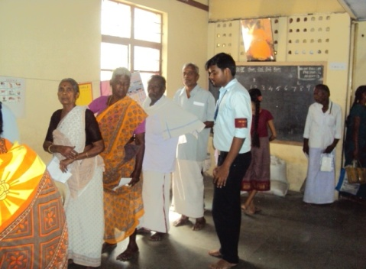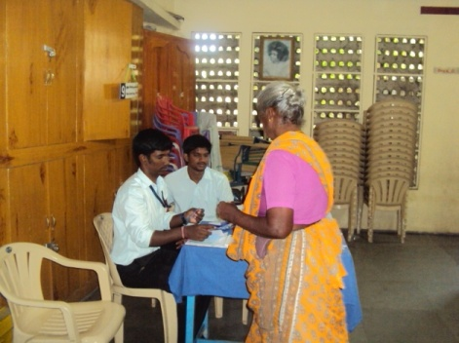

“Swami Vivekanandha’s Relevance in Meeting the Challenges of 21st Century “
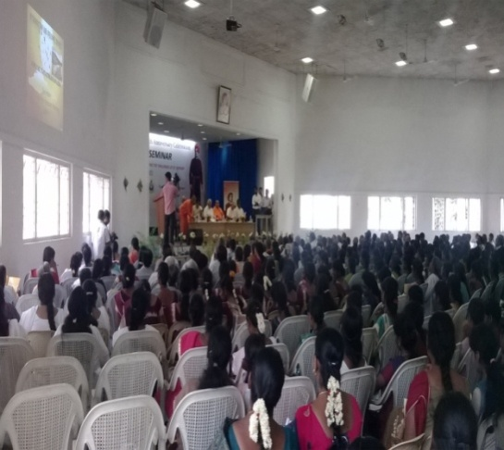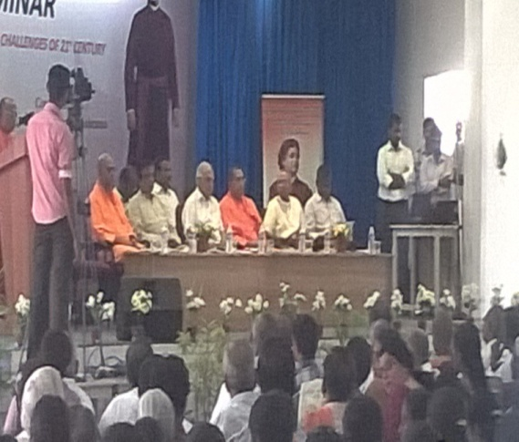

Swami Vivekanandha Ratha Yatra
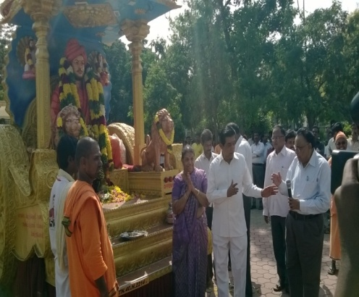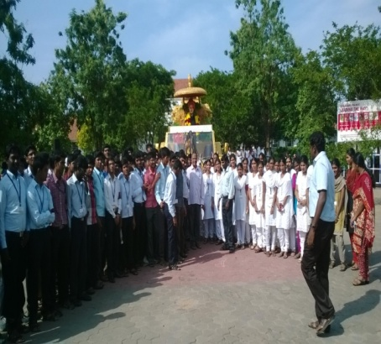
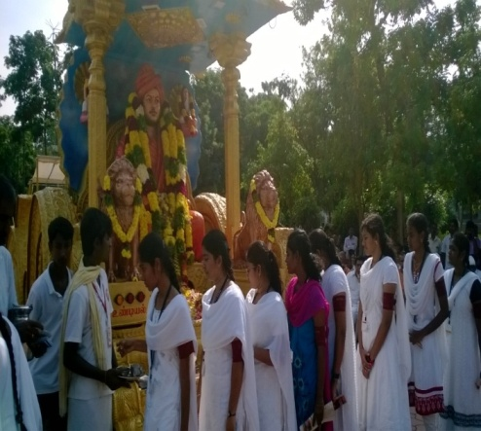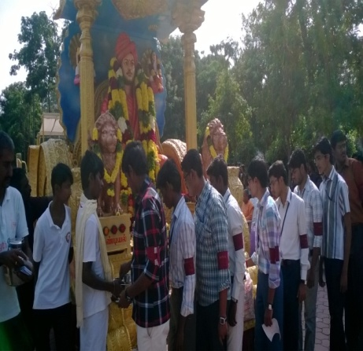

SPECIAL CAMP

