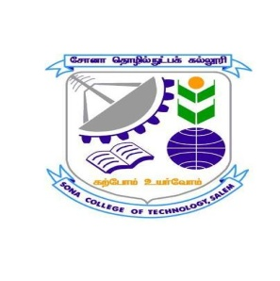 | SONA COLLEGE OF TECHNOLOGY (Autonomous)  Department of Master of Computer Applications  DST Sponsored  National Seminar on  Computational Intelligence for Healthy Farming  Innovation Challenges and Research Perspectives  18th and 19th December 2015

REGISTRATION FORM
Name (Dr./Prof./Mr./Mrs./Ms) :
Department :
Designation :
Organization :
Address : ___________________________________________________
___________________________________________________
___________________________________________________
____________________________
Phone :
Mobile :
E-Mail :
Need Accommodation (Yes/No) :
(Can be arranged subject to availability and payment)
Demand Draft Details
DD No : ____________________ Date :
Name of the Bank : ________________________________
Amount : …………………/-

Signature of the applicant

Sponsorship
Mr. /Ms ____________________________ will be permitted to participate in the two days seminar if selected.

Signature of HOD/Institution
(With office seal)

